**Day 9 - Recursion 3**

<https://www.hackerrank.com/challenges/30-recursion/problem>

**Objective**  
Today, we are learning about an algorithmic concept called recursion. Check out the [Tutorial](https://www.hackerrank.com/challenges/30-recursion/tutorial) tab for learning materials and an instructional video.

**Recursive Method for Calculating Factorial**

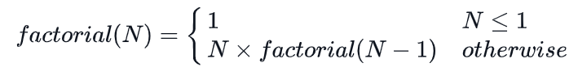

**Function Description**  
Complete the factorial function in the editor below. Be sure to use recursion.

factorial has the following paramter:

* int n: an integer

**Returns**

* int: the factorial of n

**Note:** If you fail to use recursion or fail to name your recursive function factorial or Factorial, you will get a score of 0.

**Input Format**

A single integer, n (the argument to pass to factorial).

**Constraints**

* 2 <= n <= 12
* Your submission must contain a recursive function named factorial.

**Sample Input**

3

**Sample Output**

6

**Explanation**

Consider the following steps. After the recursive calls from step 1 to 3, results are accumulated from step 3 to 1.

1. factorial (3) = 3 * factorial (2) = 3 * 2 = 6
2. factorial (2) = 2 * factorial (1) = 2 * 1 = 2
3. factorial (1) = 1